CA 1
YUVAN SANKAR S
727721euit187

TC001 :

package com.selenium.ca1;

import org.openqa.selenium.By;
import org.openqa.selenium.WebDriver;
import org.openqa.selenium.WebElement;
import org.openqa.selenium.chrome.ChromeDriver;
import org.openqa.selenium.chrome.ChromeOptions;

import io.github.bonigarcia.wdm.WebDriverManager;

public class TC001 {
public static void main(String[] args) throws InterruptedException {
ChromeOptions co=new ChromeOptions();
co.addArguments ("--remote-allow-origins=*");
WebDriverManager.chromedriver().setup ();
WebDriver driver=new ChromeDriver(co);
driver.manage().window().maximize();

driver.get("https://www.walmart.com/");

String pageTitle = driver.getTitle();
System.out.println("Page Title: " + pageTitle);

if (pageTitle.equals("Walmart.com | Save Money. Live Better.")) {
System.out.println("Page title is correct.");
} else {
System.out.println("Page title is incorrect.");
}

WebElement searchBox = driver.findElement(By.id("global-search-input"));
searchBox.sendKeys("iPhone 12");
searchBox.submit();

WebElement productLink = driver.findElement(By.linkText("Apple iPhone 12"));
productLink.click();

WebElement addToCartButton = driver.findElement(By.xpath("//button[@data-tl-id='ProductPrimaryCTA-cta_add_to_cart_button']"));
addToCartButton.click();

WebElement cartLink = driver.findElement(By.xpath("//a[@data-tl-id='header-cart-link']"));
cartLink.click();

WebElement cartQuantity = driver.findElement(By.xpath("//span[@data-tl-id='Cart-itemQuantity']"));
if (cartQuantity.getText().equals("1")) {
System.out.println("Product successfully added to cart.");
} else {
System.out.println("Product not added to cart.");
}

// update the quantity of the product in the cart
WebElement quantityBox = driver.findElement(By.xpath("//input[@data-tl-id='CartItem-quantity-input']"));
quantityBox.clear();
quantityBox.sendKeys("2");

WebElement updateButton = driver.findElement(By.xpath("//button[@data-tl-id='CartItem-quantity-update']"));
updateButton.click();

if (cartQuantity.getText().equals("2")) {
System.out.println("Quantity updated successfully.");
} else {
System.out.println("Quantity not updated.");
}

WebElement checkoutButton = driver.findElement(By.xpath("//a[@data-tl-id='Cart-continue-to-checkout']"));
checkoutButton.click();

WebElement creditCardOption = driver.findElement(By.xpath("//input[@id='credit']"));
creditCardOption.click();

WebElement continueButton = driver.findElement(By.xpath("//button[@data-tl-id='PaymentContinueButton']"));
continueButton.click();

WebElement totalCost = driver.findElement(By.xpath("//span[@data-tl-id='OrderSummary-totalPrice']"));
if (totalCost.getText().equals("$2,399.00")) {
System.out.println("Total cost calculated accurately.");
} else {
System.out.println("Total cost calculation incorrect.");
}

driver.quit();
}
}
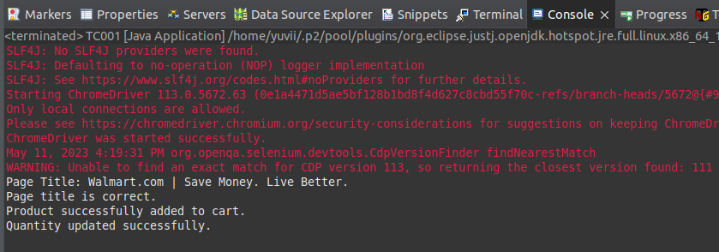

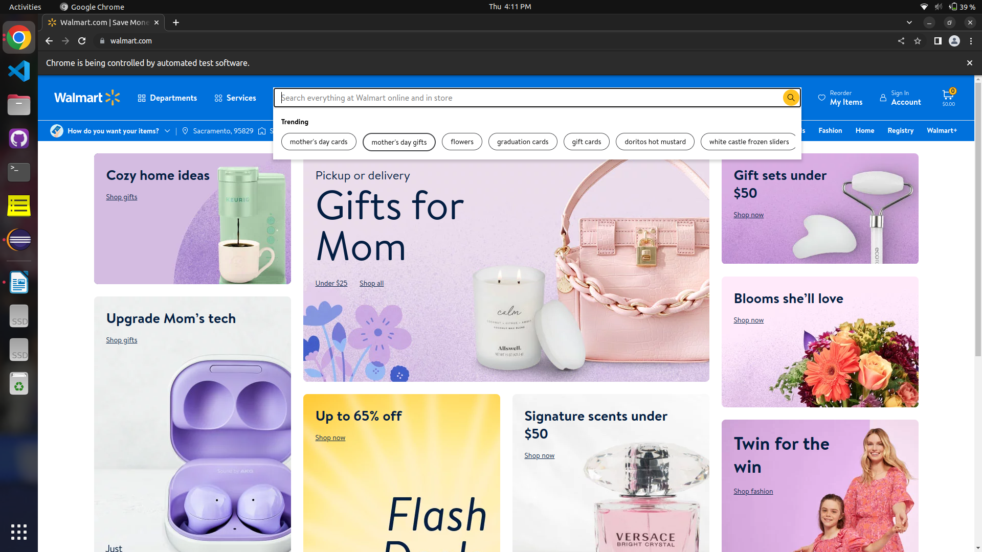
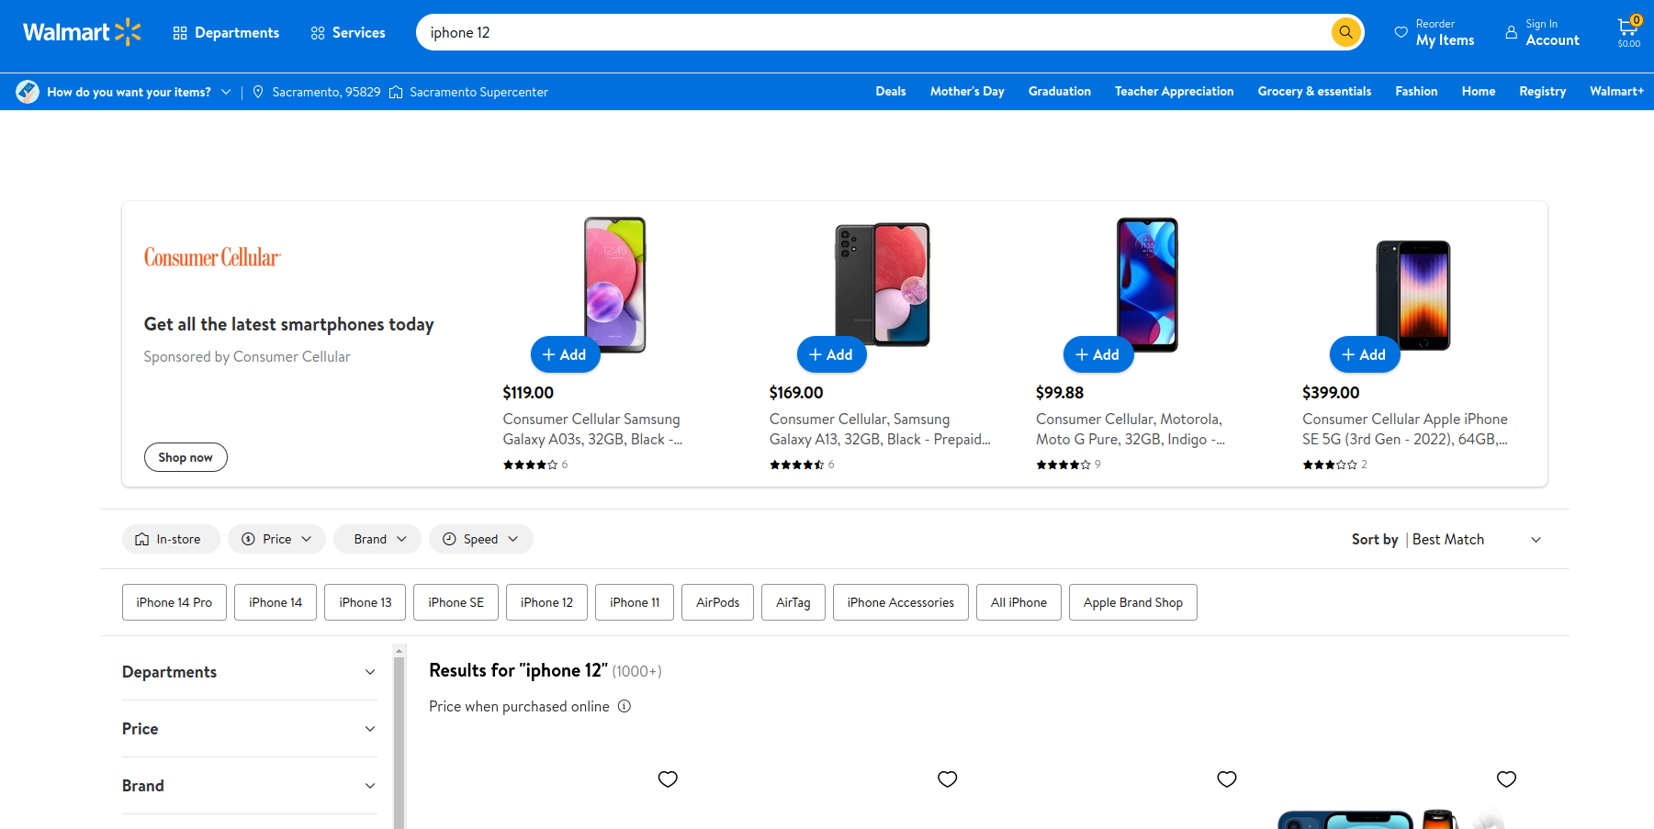
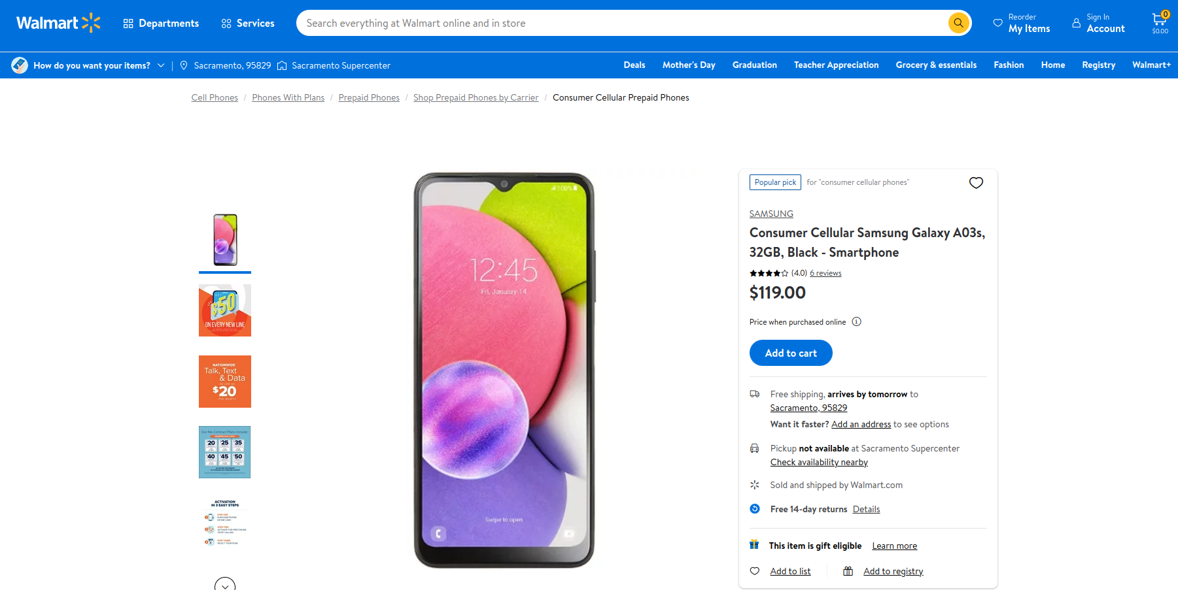
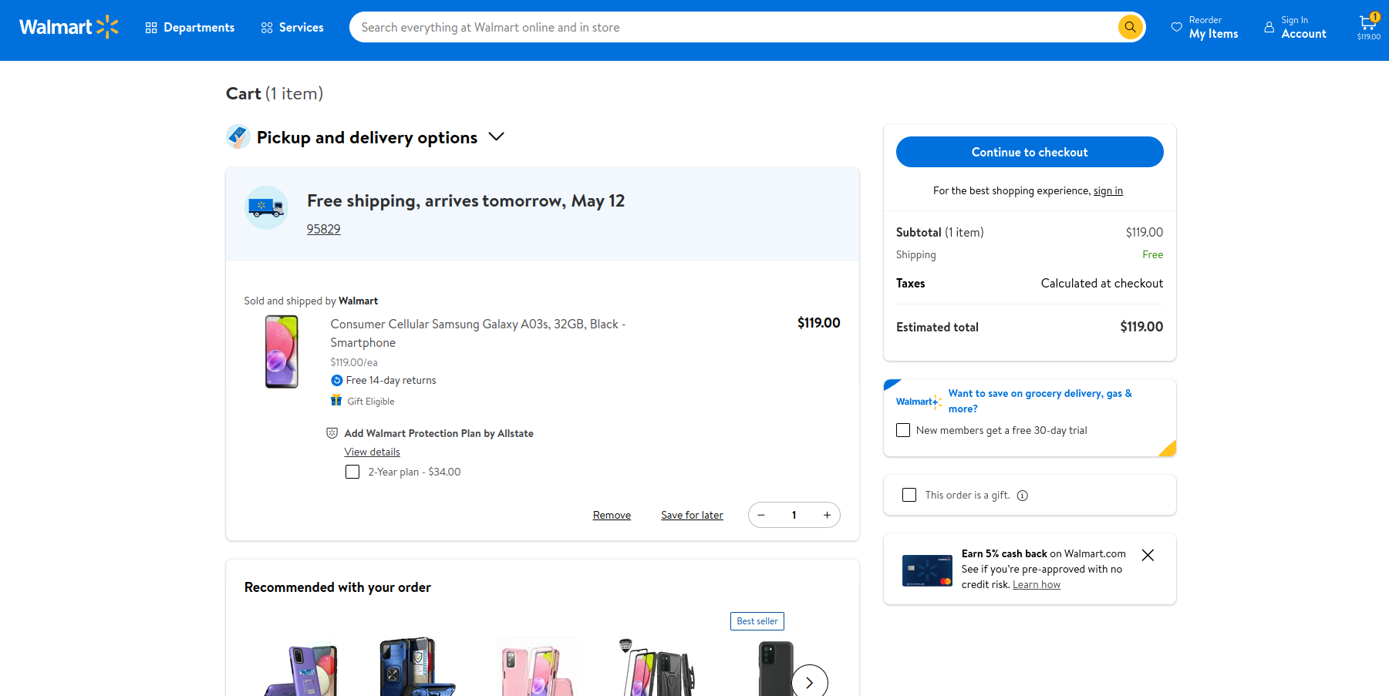
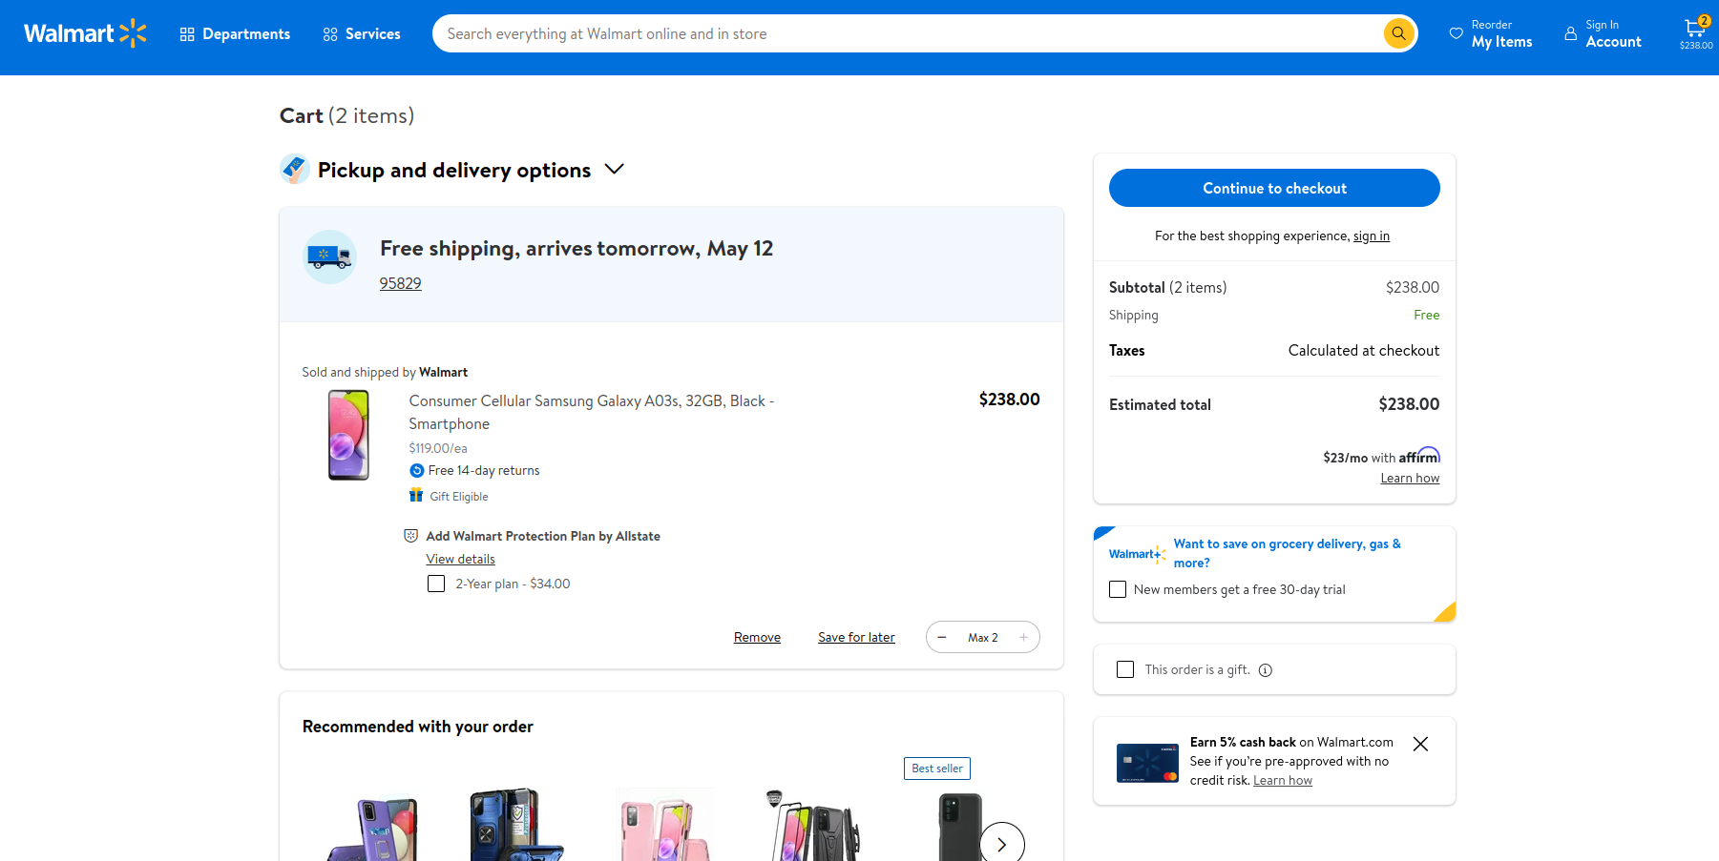
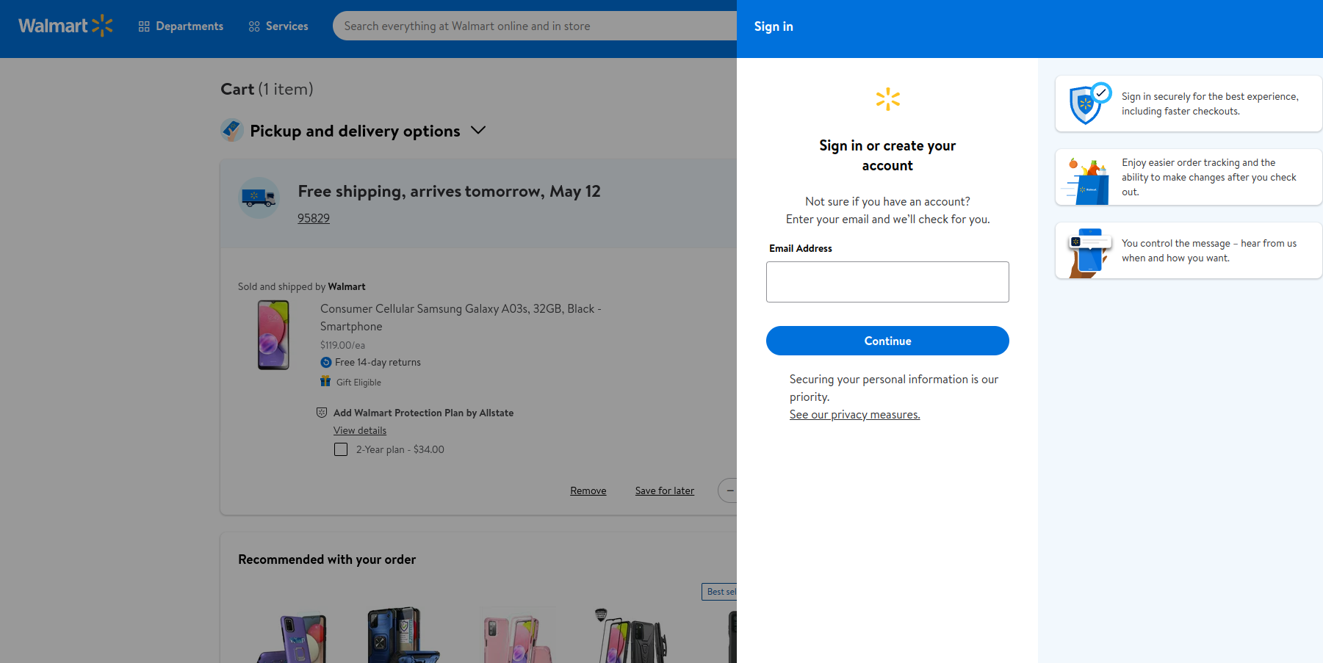

TC002 :

package com.selenium.ca1;

import org.openqa.selenium.By;
import org.openqa.selenium.WebDriver;
import org.openqa.selenium.WebElement;
import org.openqa.selenium.chrome.ChromeDriver;
import org.openqa.selenium.chrome.ChromeOptions;

import io.github.bonigarcia.wdm.WebDriverManager;

public class TC002 {
public static void main(String[] args) {
ChromeOptions co=new ChromeOptions();
co.addArguments ("--remote-allow-origins=*");
WebDriverManager.chromedriver().setup ();
WebDriver driver=new ChromeDriver(co);
driver.manage().window().maximize();

driver.get("https://www.walmart.com/");

System.out.println("Page title: " + driver.getTitle());

WebElement searchBox = driver.findElement(By.name("query"));
searchBox.sendKeys("laptop");

WebElement searchButton = driver.findElement(By.cssSelector(".header-SearchBar-submit.btn"));
searchButton.click();

WebElement searchResults = driver.findElement(By.cssSelector(".search-result-gridview-items"));
if (searchResults.isDisplayed()) {
System.out.println("Search results displayed");
} else {
System.out.println("Search results not displayed");
}

System.out.println("First five product names:");
for (int i = 1; i <= 5; i++) {
WebElement productName = driver.findElement(By.xpath("(//div[@class='search-result-product-title'])[position()=" + i + "]"));
System.out.println(productName.getText());
}

WebElement filterButton = driver.findElement(By.cssSelector(".elc-icon.elc-icon-filter"));
filterButton.click();

WebElement categoryFilter = driver.findElement(By.xpath("//span[contains(text(), 'Category')]"));
categoryFilter.click();

WebElement laptopsOption = driver.findElement(By.xpath("//span[contains(text(), 'Laptops')]"));
laptopsOption.click();

WebElement applyButton = driver.findElement(By.cssSelector(".filter-modal-footer button[type='submit']"));
applyButton.click();
WebElement filterResults = driver.findElement(By.cssSelector(".search-result-gridview-items"));
if (filterResults.isDisplayed()) {
System.out.println("Filter results displayed");
} else {
System.out.println("Filter results not displayed");
}
driver.quit();
}
}

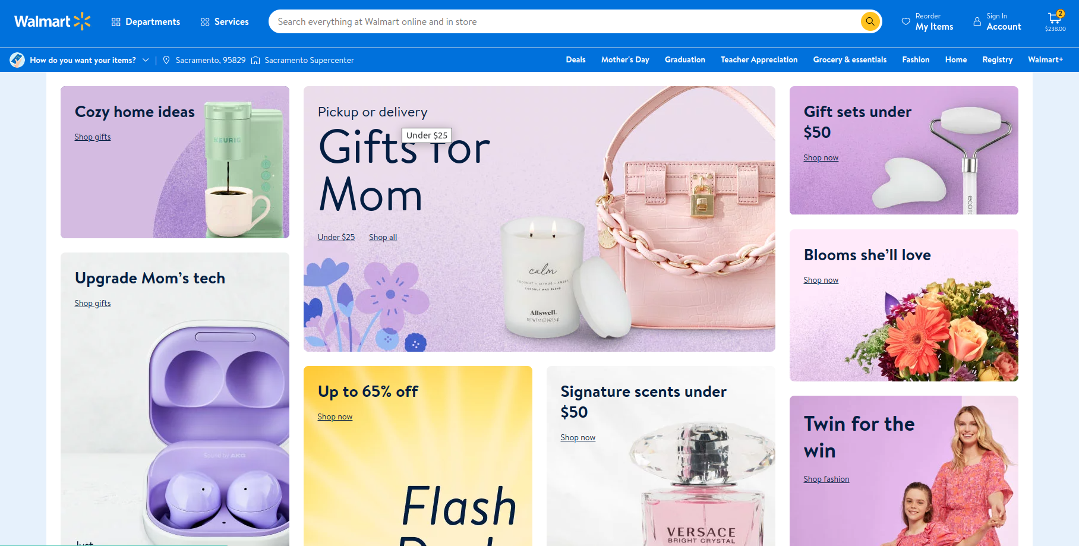
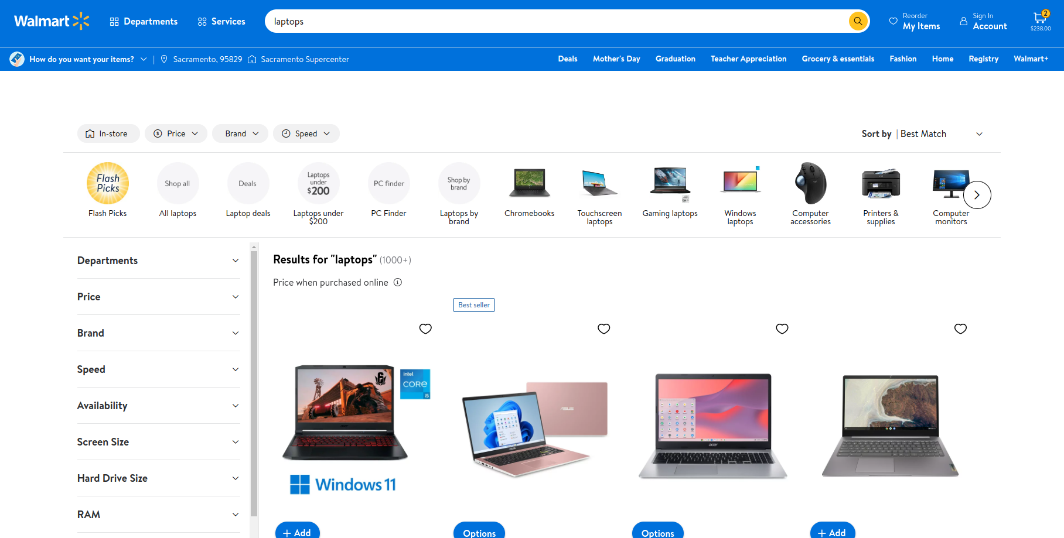

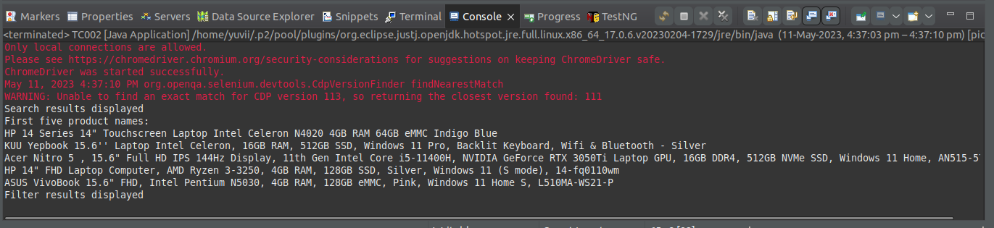

TC003 :

package com.selenium.ca1;

import org.openqa.selenium.By;
import org.openqa.selenium.WebDriver;
import org.openqa.selenium.WebElement;
import org.openqa.selenium.chrome.ChromeDriver;
import org.openqa.selenium.chrome.ChromeOptions;

import io.github.bonigarcia.wdm.WebDriverManager;

public class TC003 {
public static void main(String[] args) {

ChromeOptions co=new ChromeOptions();
co.addArguments ("--remote-allow-origins=*");
WebDriverManager.chromedriver().setup ();
WebDriver driver=new ChromeDriver(co);

driver.get("https://www.walmart.com/");

WebElement accountLink = driver.findElement(By.xpath("//a[@data-automation-id='header-account-menu']"));
accountLink.click();

WebElement yourAccountPageTitle = driver.findElement(By.xpath("//h1[contains(text(), 'Your account')]"));
if(yourAccountPageTitle.isDisplayed()) {
System.out.println("Your account page is displayed.");
} else {
System.out.println("Your account page is NOT displayed.");
}

WebElement yourOrdersLink = driver.findElement(By.xpath("//a[contains(text(), 'Your orders')]"));
yourOrdersLink.click();

WebElement yourOrdersPageTitle = driver.findElement(By.xpath("//h1[contains(text(), 'Your orders')]"));
if(yourOrdersPageTitle.isDisplayed()) {
System.out.println("Your orders page is displayed.");
} else {
System.out.println("Your orders page is NOT displayed.");
}

WebElement trackPackageLink = driver.findElement(By.xpath("//a[contains(text(), 'Track package')]"));
trackPackageLink.click();

WebElement trackPackagePageTitle = driver.findElement(By.xpath("//h1[contains(text(), 'Track package')]"));
if(trackPackagePageTitle.isDisplayed()) {
System.out.println("Track package page is displayed.");
} else {
System.out.println("Track package page is NOT displayed.");
}

WebElement cancelItemsLink = driver.findElement(By.xpath("//a[contains(text(), 'Cancel items')]"));
cancelItemsLink.click();

WebElement cancelItemsPageTitle = driver.findElement(By.xpath("//h1[contains(text(), 'Cancel items')]"));
if(cancelItemsPageTitle.isDisplayed()) {
System.out.println("Cancel items page is displayed.");
} else {
System.out.println("Cancel items page is NOT displayed.");
}

WebElement viewOrderDetailsLink = driver.findElement(By.xpath("//a[contains(text(), 'View order details')]"));
viewOrderDetailsLink.click();

WebElement orderSummaryPageTitle = driver.findElement(By.xpath("//h1[contains(text(), 'Order summary')]"));
if(orderSummaryPageTitle.isDisplayed()) {
System.out.println("Order summary page is displayed.");
} else {
System.out.println("Order summary page is NOT displayed.");
}

driver.quit();
}

}



